**Assignment 3**

**1. (30 marks) Pages 158-159 (Problem Set),**

**Questions 3: Rewrite the BNF of Example 3.4 to give + precedence over * and force + to be right associative.** 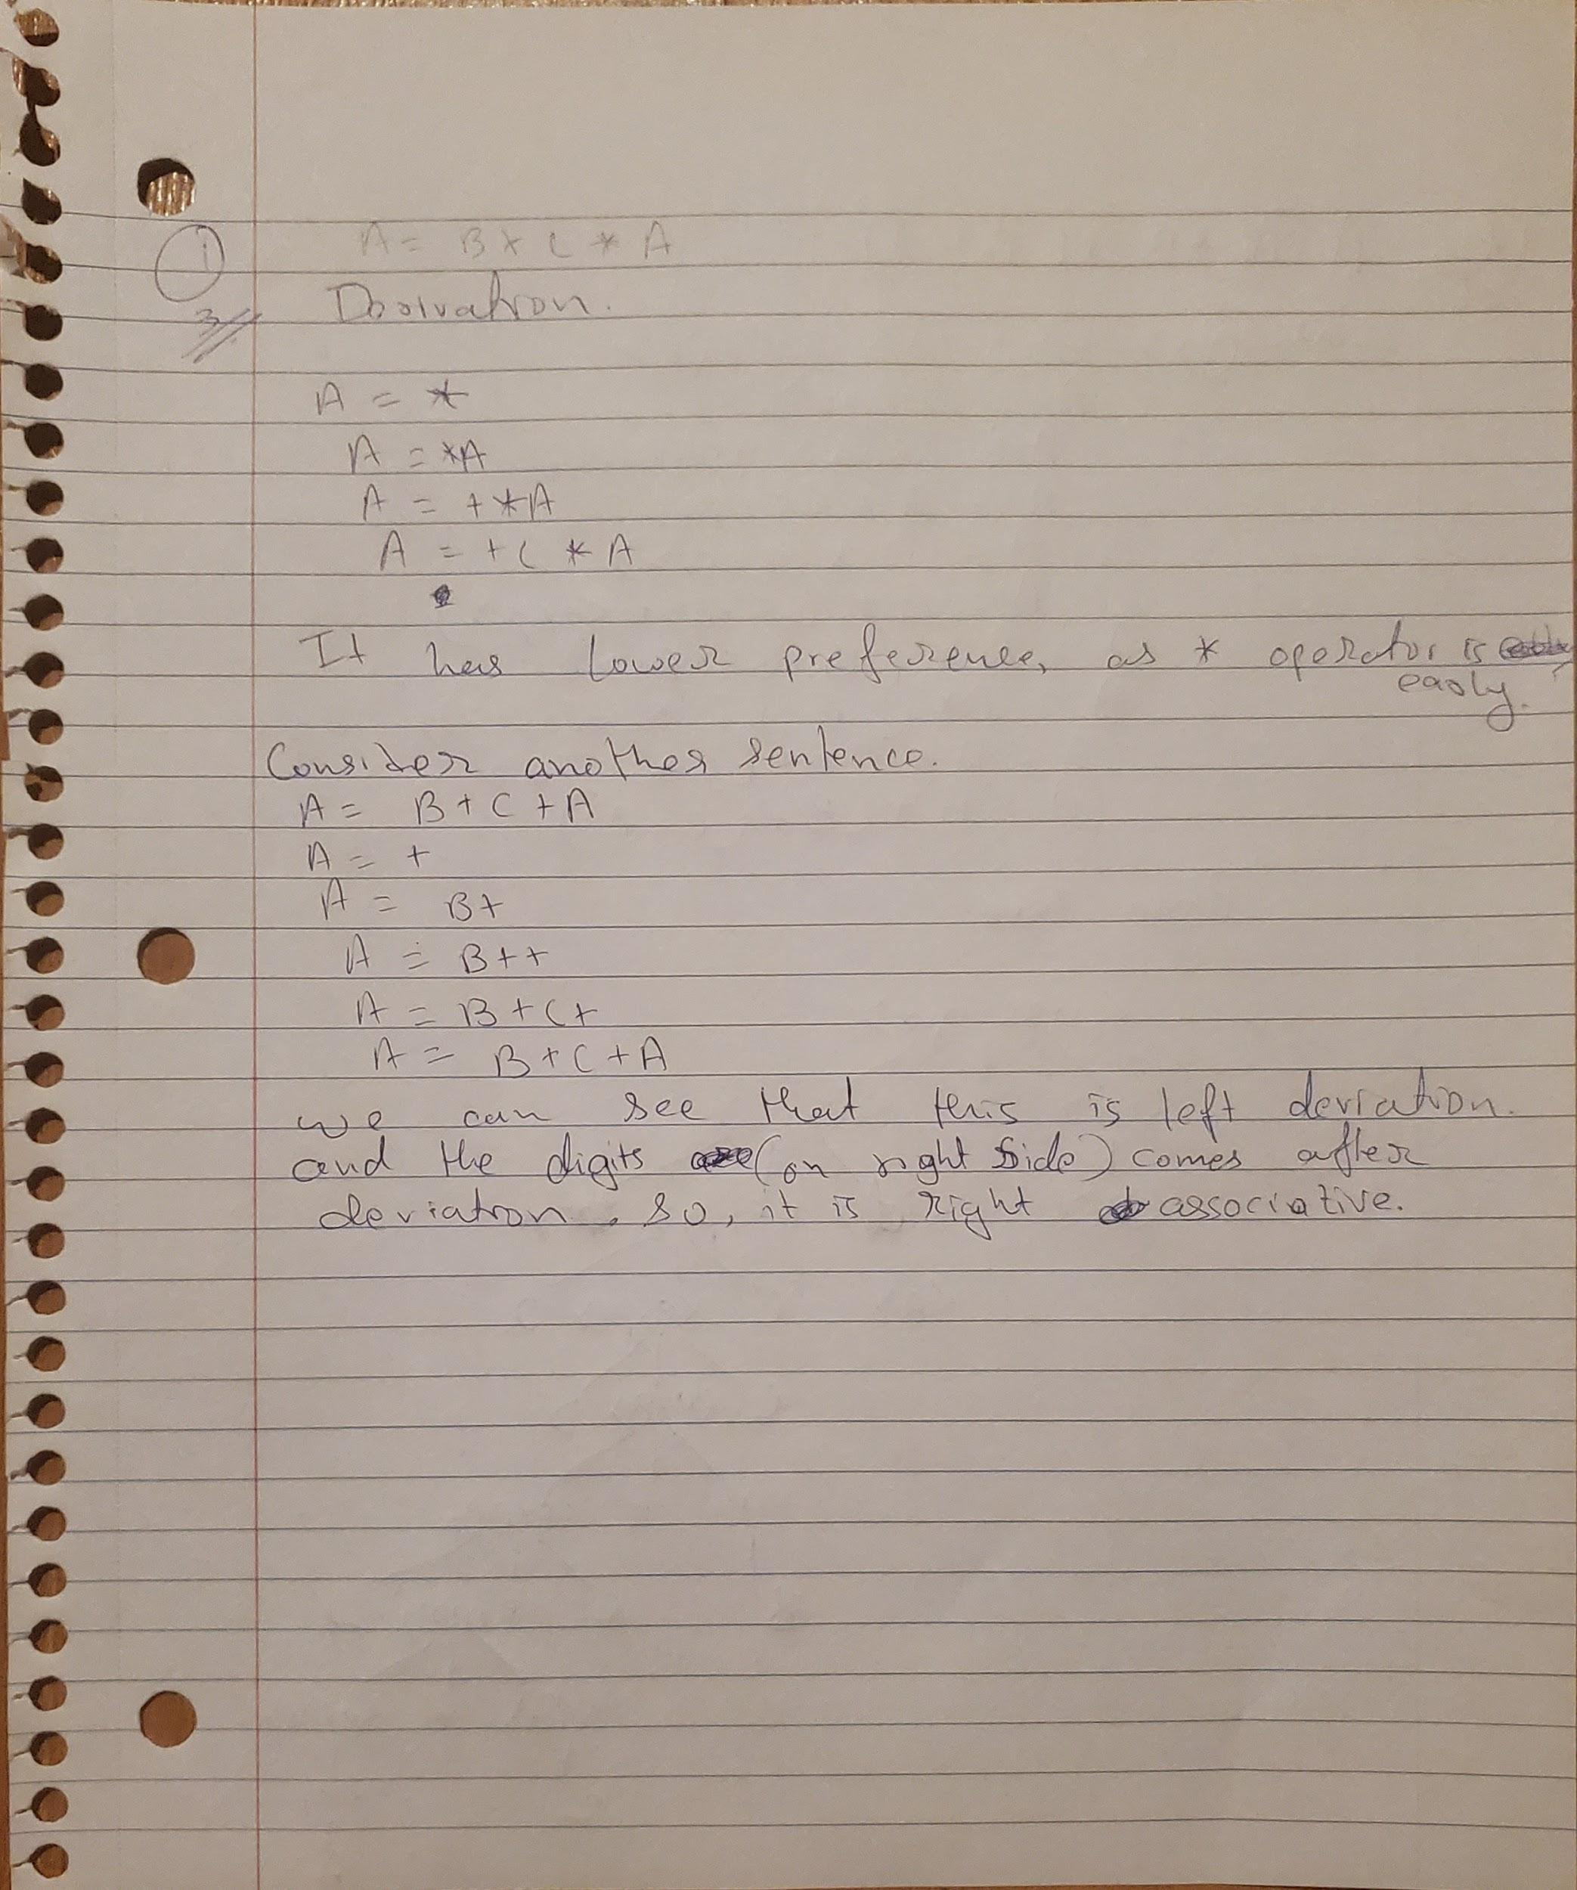

**Questions 6: Using the grammar in Example 3.2, show a parse tree and a leftmost**

**derivation for each of the following statements:**

**a. A = A * (B + (C * A))**

**b. B = C * (A * C + B)**

**c. A = A * (B + (C))**

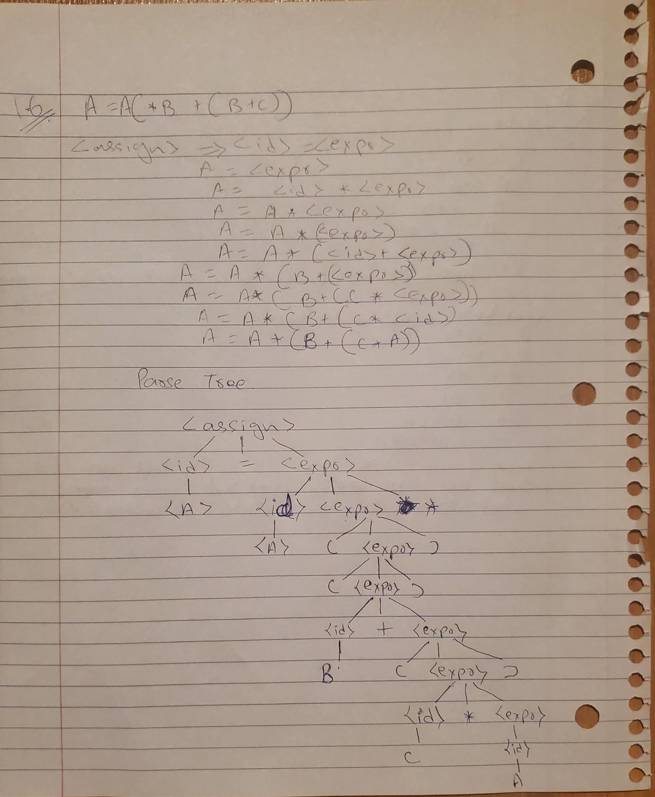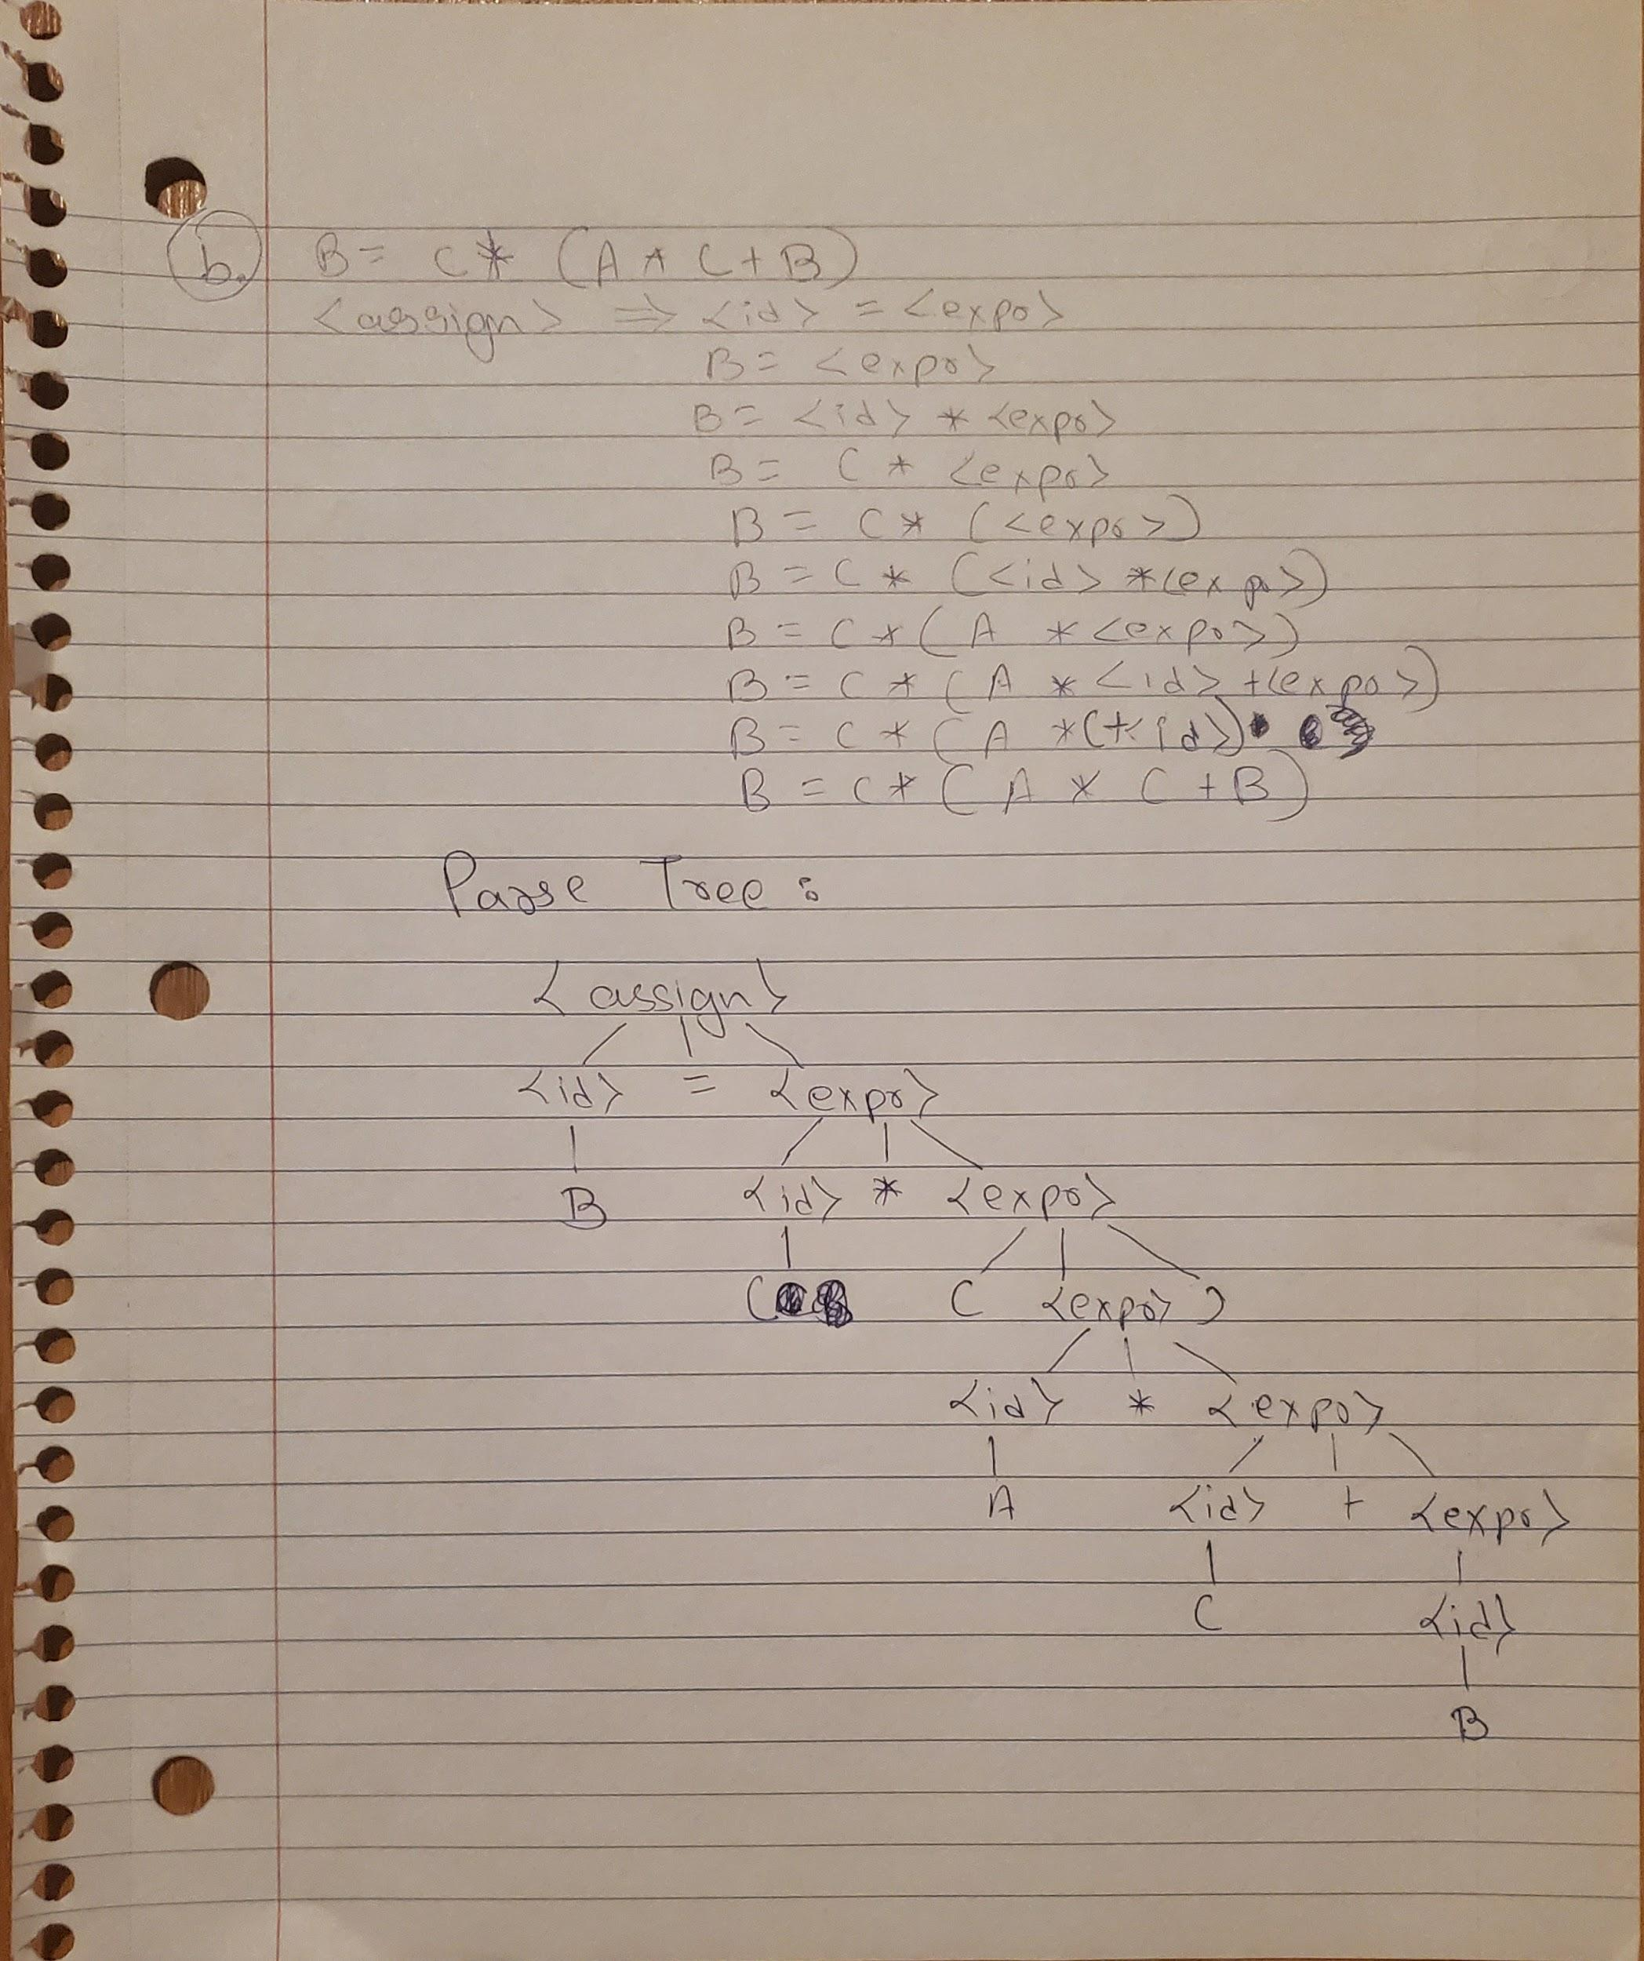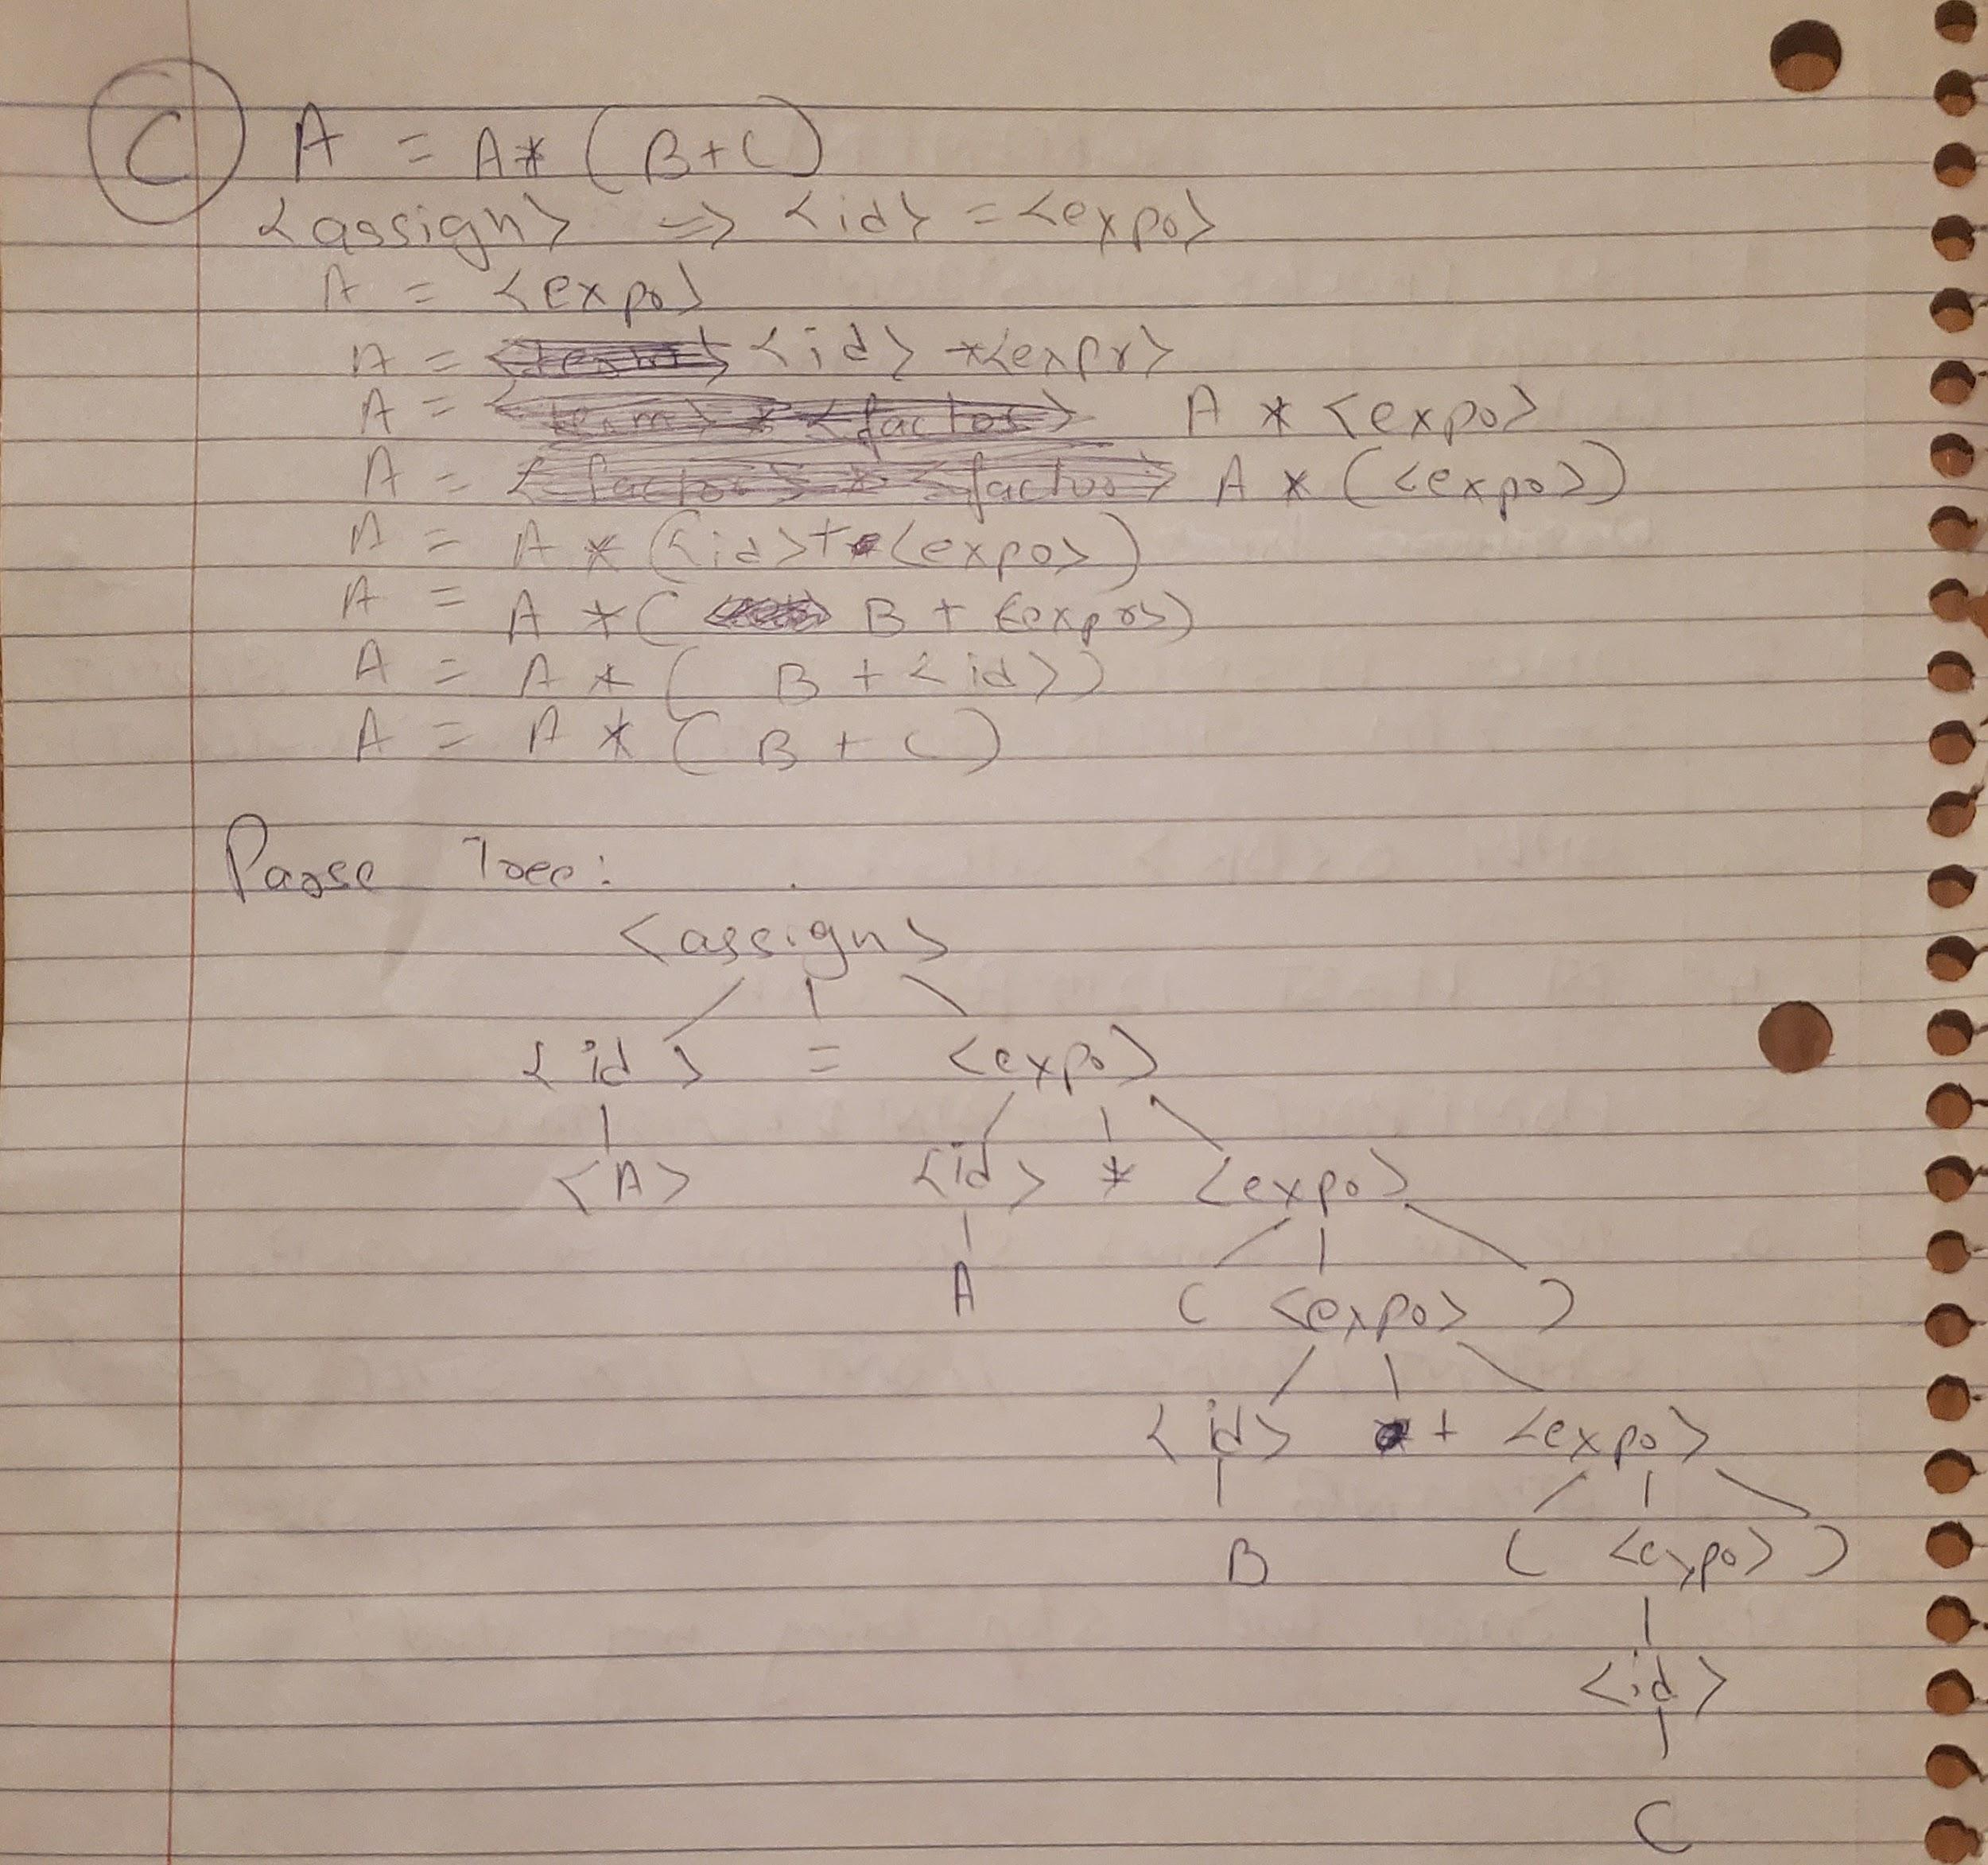

**Questions 7: Using the grammar in Example 3.4, show a parse tree and a leftmost**

**derivation for each of the following statements:**

**a. A = ( A + B ) * C**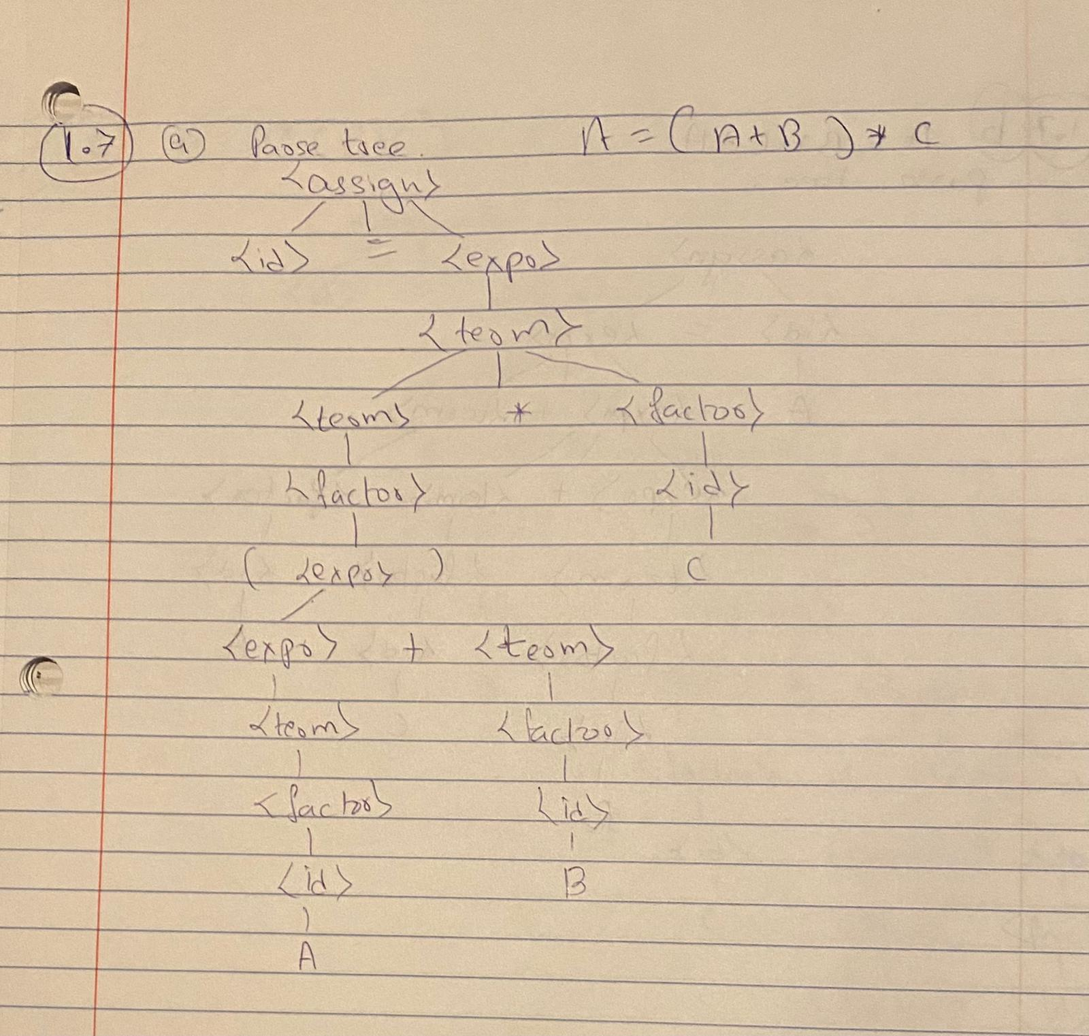

**b. A = B + C + A**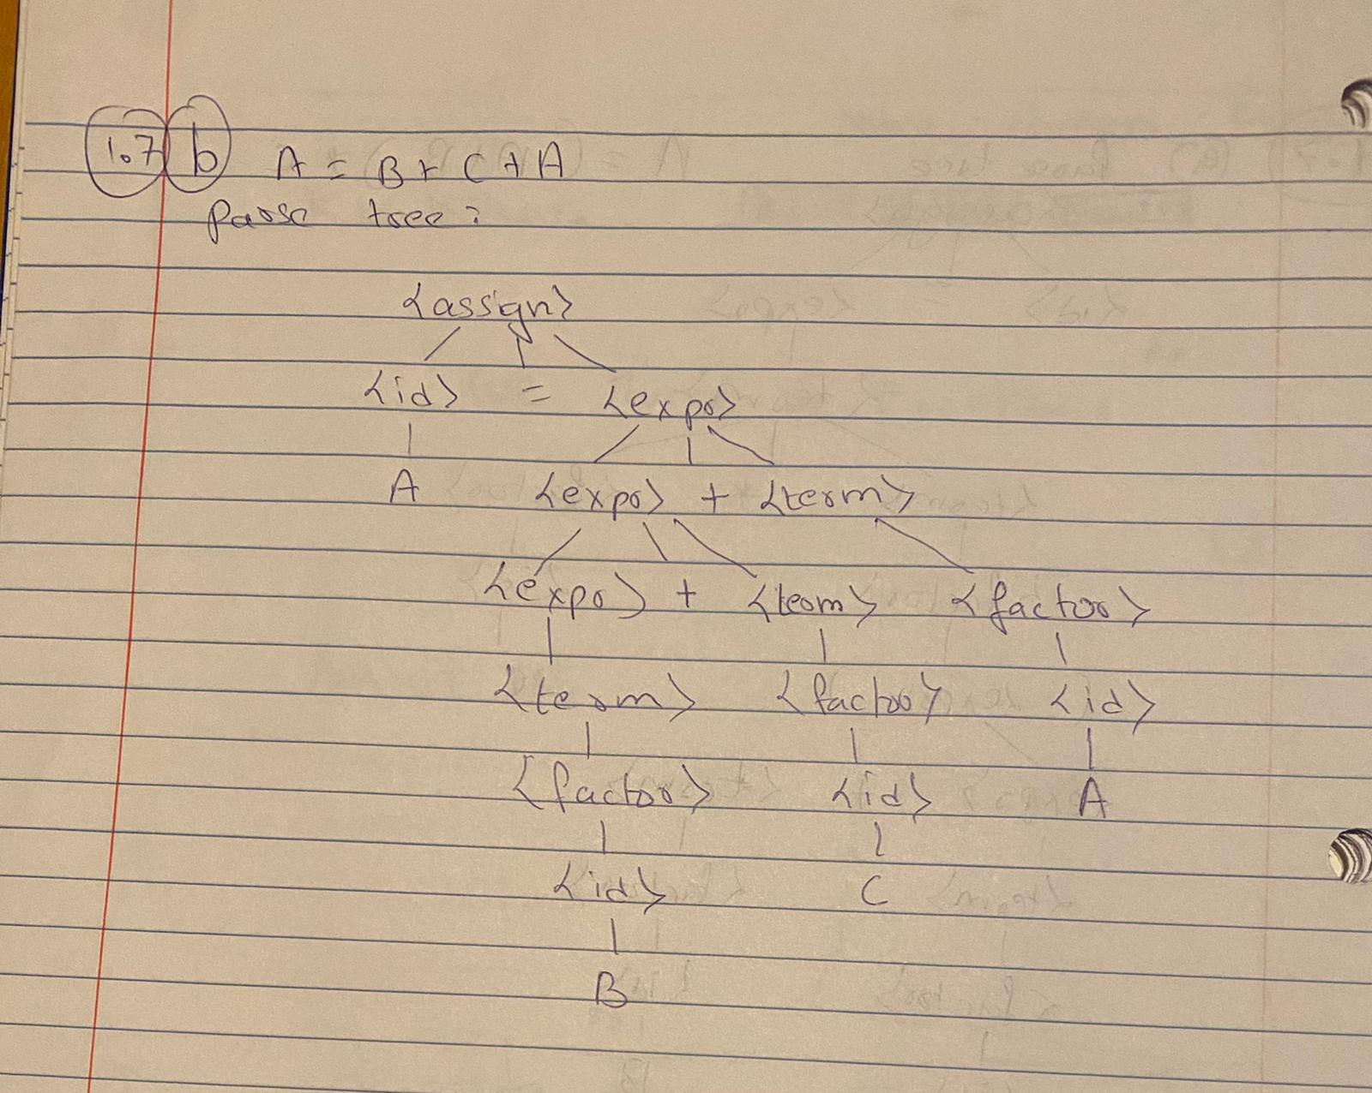

**c. A = A * (B + C)**

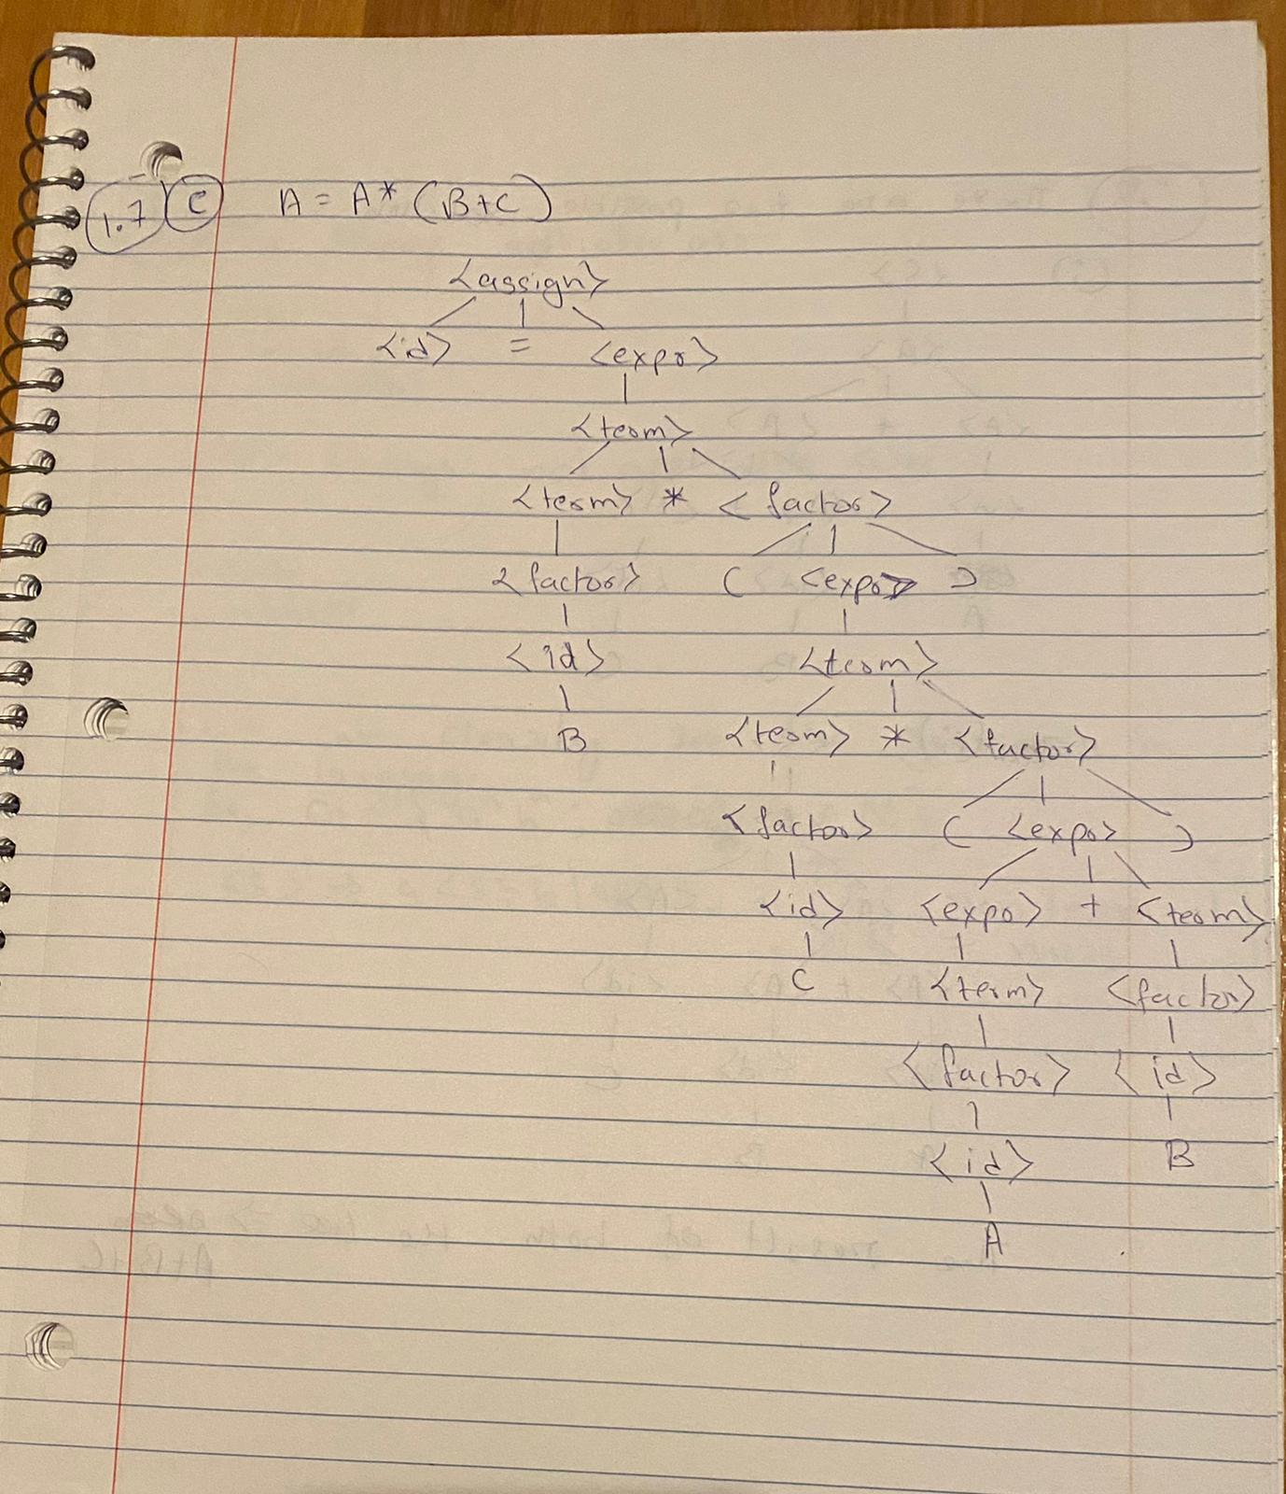

**Questions 8: Prove that the following grammar is ambiguous:**

**<S> → <A>**

**<A> → <A> + <A> | <id>**

**<id> → a | b | c**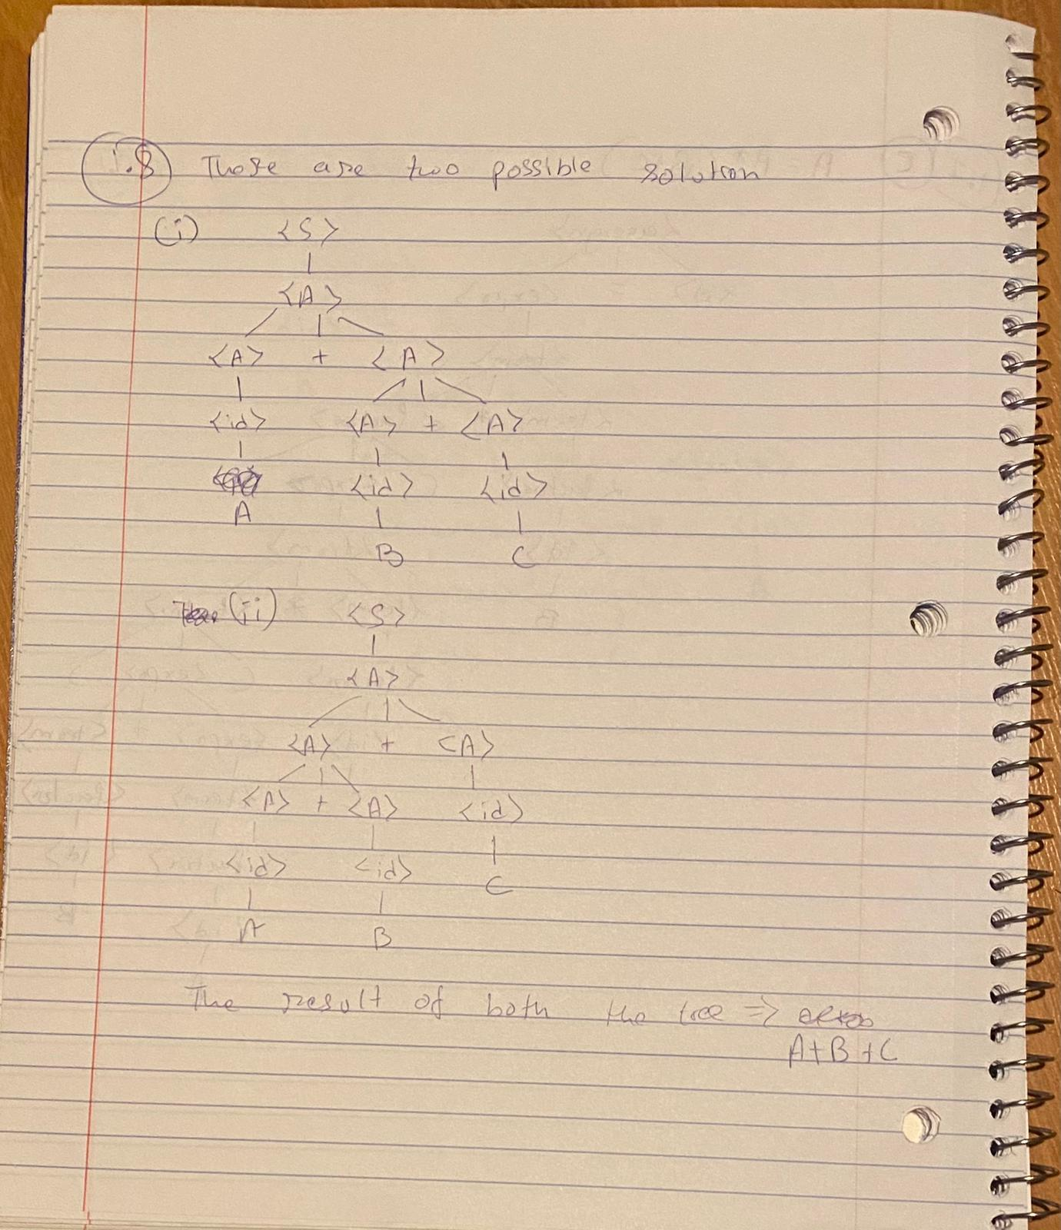

**Questions 13: Write a grammar for the language consisting of strings that have n copies of the letter a followed by one more number of copies of the letter b, where n > 0. For example, the strings abb, aaaabbbbb, and aaaaaaaabbbbbbbbb are in the language but a, ab, ba, and aaabb are not.**

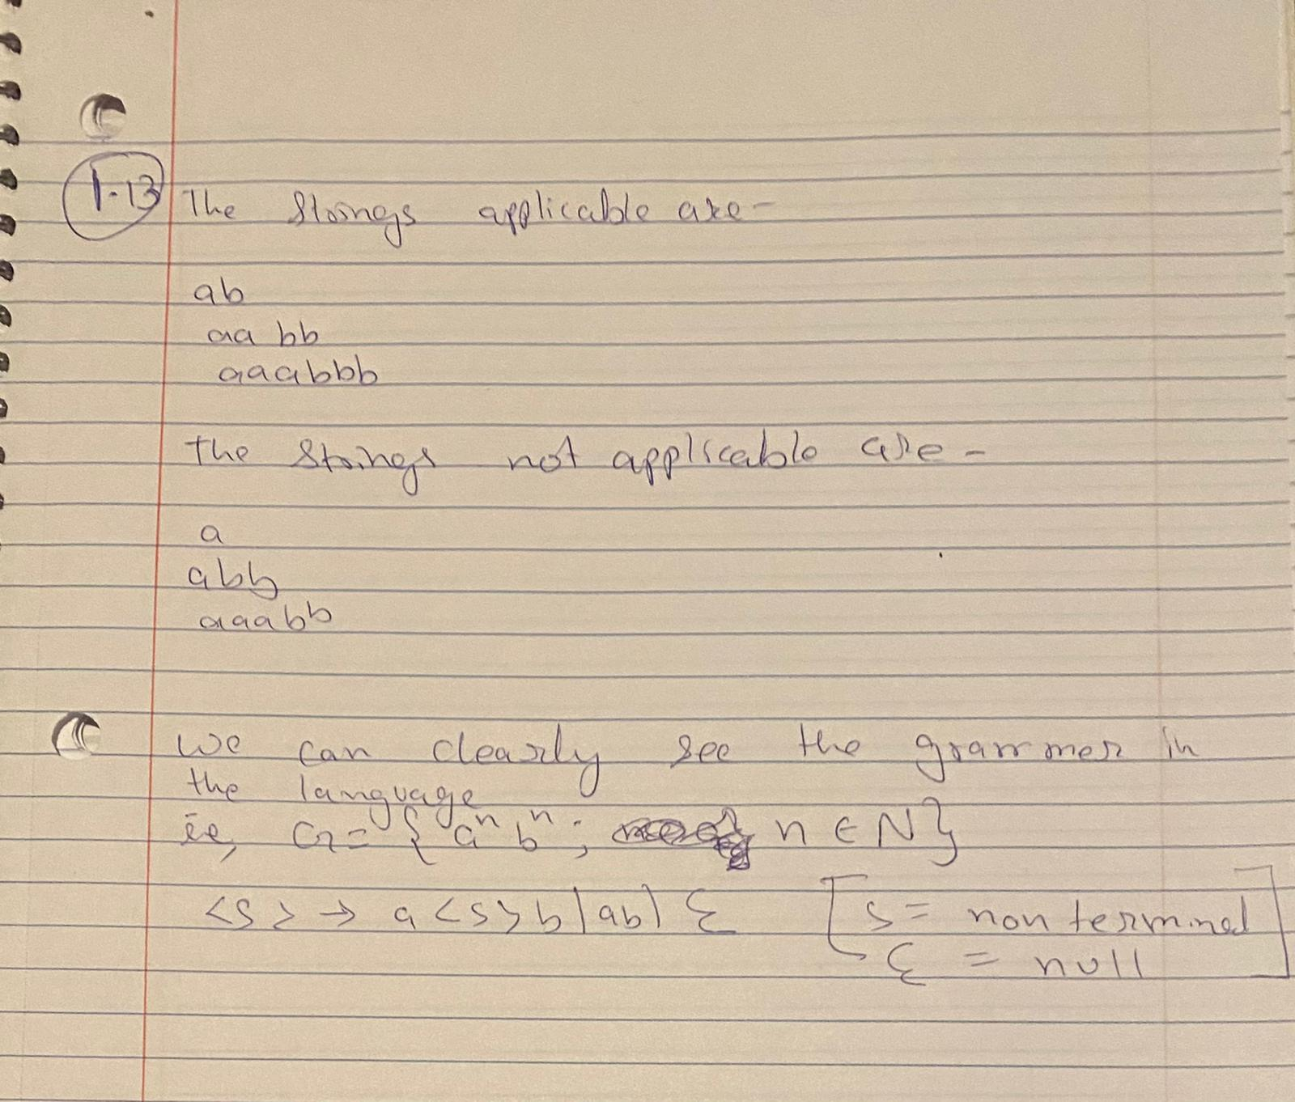

**2. (20 marks) Use any language for the question (Hand in source programs and test runs).**

**Consider the following grammar for arithmetic expressions:**

**E —-> T**

**E —-> E + T**

**T —-> F**

**T —-> T * F**

**F —-> int**

**F —-> (E)**

**where int denotes an integer.**

1. **Modify the rules to remove left recursion (you may use EBNF).**
2. **Suppose that the value of an expression is given by its corresponding post-fix expression. Add the semantics rules computing the value of an expression.**
3. **Modify the program (given in the text and in the PPT) for parsing an arithmetic expression to produce a post-fix expression from an in-fix expression.**
4. **Do b) and c) for pre-fix expression.**
5. **Give grammar rules for post-fix expressions. Give semantics rules for computing a post-fix expressions. Write a program to compute the value of a post-fix expression**

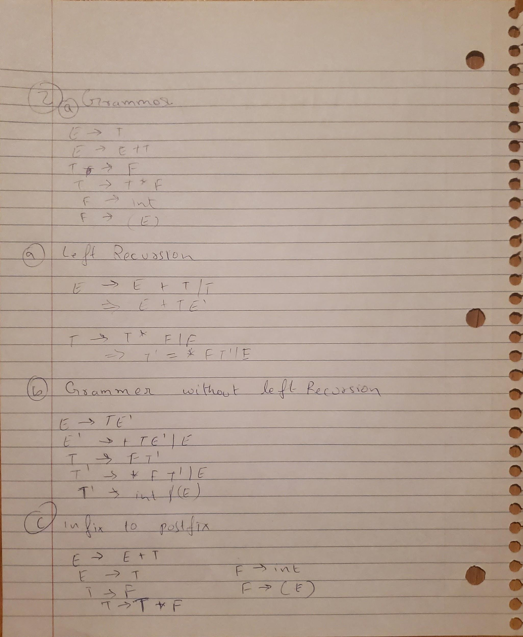

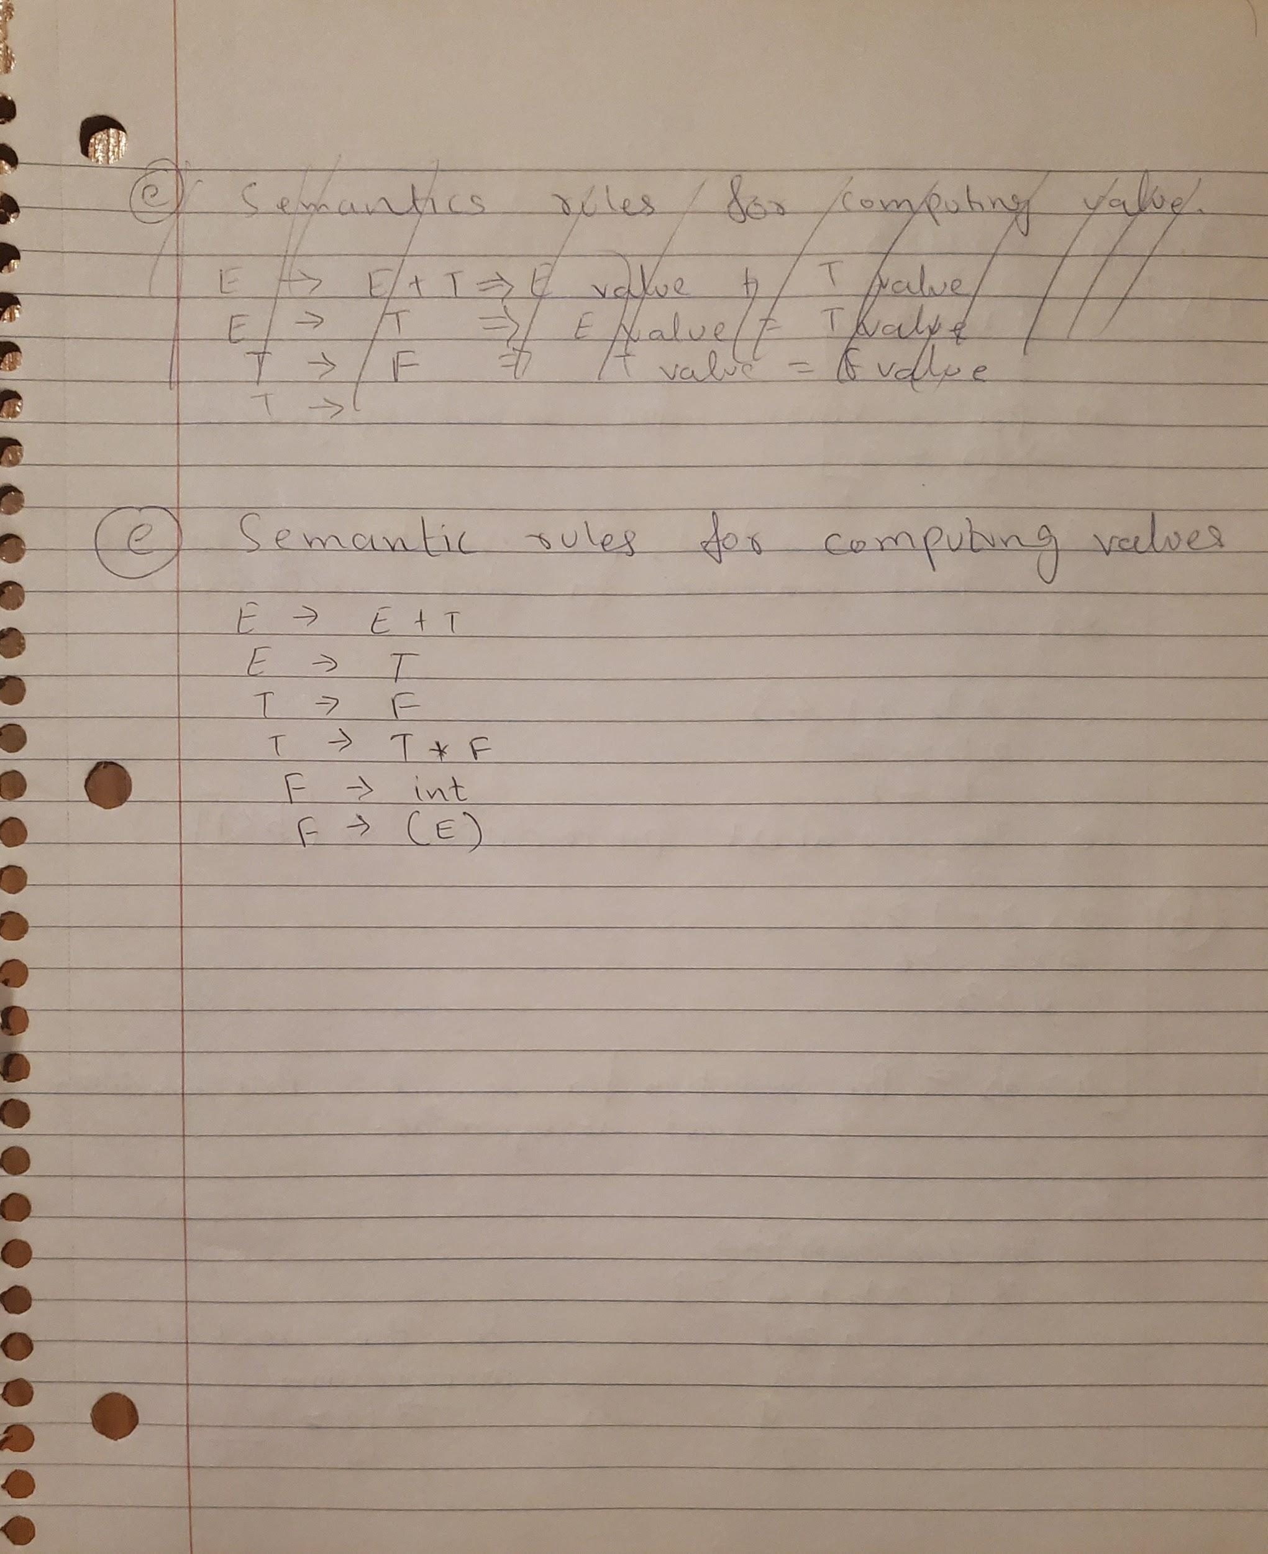

**3. (10 marks) Page 160 (Problem Set):**

**Question 24: Compute the weakest precondition for the following sequence of assignment statements, for the postcondition given.**

**a) a = 2 * b + 1; b = a – 3 {b < 0}**

[**b)**](https://www.chegg.com/homework-help/questions-and-answers/2-compute-weakest-precondition-wp-following-sequences-assignment-statements-postconditions-q24246492) **a = 3 * (2 * b + a); b = 2 * a - 1 {b > 5}**

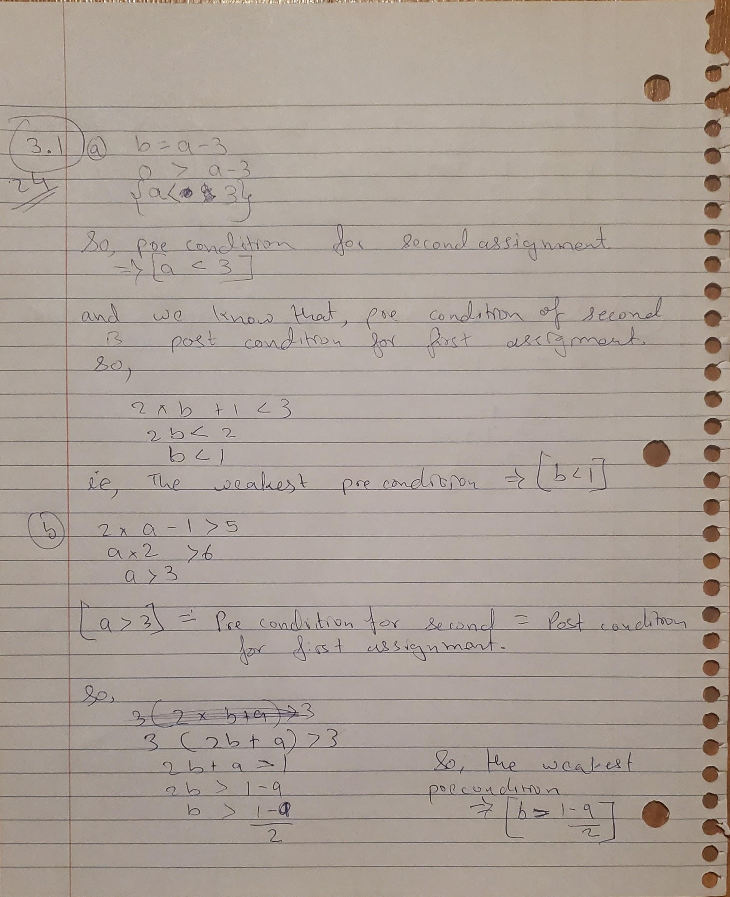

**Question 25: Compute the weakest precondition for each of the following selection constructs and their postconditions:**

1. if (a == b)

b = 2 * a + 1;

else

b = 2 * a;

{b > 1}

1. if (x < y)

x = x + 1;

else

x = 3 * x;

{x < 0}

1. If (x > y)

y = 2 * x + 1;

else

Y = 3 * x - 1;

{y > 3}

